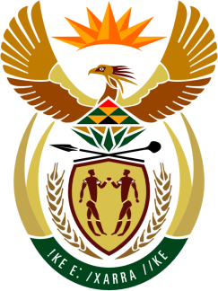

**SOUTH AFRICAN PERMANENT MISSION**

**TO THE UNITED NATIONS**

**AND OTHER INTERNATIONAL ORGANISATIONS**

**45th SESSION OF THE WORKING GROUP ON THE**

**UNIVERSAL PERIODIC REVIEW**

**Review of CAR**

**26 JANUARY 2024**

**(85 Seconds)**

**speaker no: 35**

***Check against delivery***

Mr. President,

South Africa welcomes the distinguished delegation of the Central African Republic (CAR) to this UPR Session and wishes the country a successful review.

South Africa acknowledges CAR’s efforts to implement the recommendations made during the 3rd UPR Review Cycle, under challenging circumstances. We commend the work undertaken to bring the country’s legislative framework into compliance with its human rights obligations and joins with the African Commission on Human and Peoples’ Rights in welcoming the adoption of the law to abolish the death penalty (2022). We also commend the development of the country’s national policy on human rights (2023), together with the associated sector specific policies in areas such as health and education.

South Africa wishes to make the following recommendations:

* Continue initiatives to combat impunity for sexual and other forms of gender-based violence by strengthening the criminal justice system and encouraging victims to report the perpetrators;
* Continue efforts to ensure compliance with the 2019 peace agreement and provide the Truth, Justice, Reparation and Reconciliation Commission with the resources and means necessary to fulfil its mandate; and
* Continue programmes to remove inequalities confronted by persons with disabilities, including implementing an inclusive education policy, together with the provision of support services to schools in this regard.

I thank you.